GUIDELINES FOR POSTER PRESENTATION
Poster abstracts must present original data and results. Literature reviews or purely theoretical work are not eligible. The abstract should clearly state:
- The scientific question or problem addressed
- The key methods employed
- The main results achieved
- The conclusions drawn from the data
- Poster abstracts should be readable, clear, and concise, effectively communicating research findings and their broader scientific significance to a general biotechnology or interdisciplinary audience.

Printing and Display Requirements
Your poster must be printed as a bunting banner style (flexible fabric or similar material suitable for rolling/folding, with reinforced top and bottom edges/poles ready for hanging).
A poster stands tripod will be provided by the organizer (excluding the pole/rod for hanging the banner itself).
Poster dimensions: 2 feet (width) × 4 feet (height): equivalent to approximately 60 cm × 120 cm (portrait orientation).
Ensure your design fits exactly within these dimensions (no bleeds or oversizing).
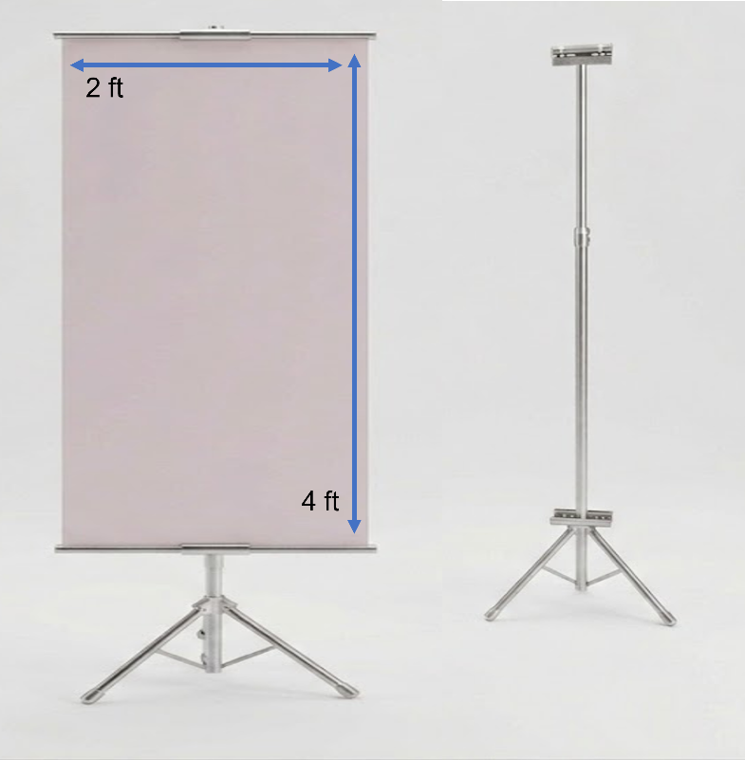
Use high-resolution elements (300 dpi minimum) to avoid pixelation when printed.

Design and Content Best Practices
To create an effective poster that attracts viewers and facilitates discussion:
1) Keep text minimal: Limit total text to ~500–800 words (ideally closer to 300–500). Use short bullet points, phrases, and active voice instead of full paragraphs or passive constructions.
2) Prioritize visuals: Emphasize graphs, charts, diagrams, schematics, photos, and models (~40–60% of poster space). Replace dense text or tables with clear, simplified figures. Include error bars, legends, and annotations where relevant.
3) Logical flow and layout: Organize content in 2–4 columns with a natural left-to-right, top-to-bottom reading order. Place the most important result or central visual in the middle or upper area for maximum impact. Use clear section headings (e.g., Research Question, Methods, Key Results, Conclusions) to guide the viewer.
4) Font and readability:
Title: 72–100+ pt (bold, eye-catching from 5–10 feet away)
Section headings: 40–60 pt
Body text / figure captions: Minimum 24–36 pt (legible from ~6–10 feet)
Use sans-serif fonts (e.g., Arial, Helvetica, Calibri, Roboto) consistently for clarity.

Color Scheme and Contrast
Choose a simple, cohesive palette of 2–4 colors (e.g., muted background with 1–2 accent colors for emphasis).
Preferred: Light or white background with dark text for best readability.
Avoid bright/fluorescent colors, busy patterns, gradients, or rainbow effects unless they meaningfully highlight data.
Ensure high contrast (e.g., dark text on light background) and color-blind accessibility (avoid red-green pairings; test with tools like ColorBrewer or simulators).
Use color purposefully: to group related sections, highlight key findings, or differentiate data categories—not for decoration.

Additional Tips
Include a large, engaging title that poses a question or highlights the main finding.
Add a QR code linking to full paper, data, or supplementary materials (if applicable).
Proofread carefully: typos undermine credibility.
Design for stand-alone understanding (someone should grasp the core message in 10–30 seconds even without you present).

Do follow these guidelines to ensure your poster is professional, accessible, and engaging. A well-designed poster not only communicates your science effectively but also serves as an excellent conversation starter during the session.

